Ideation Phase
Define the Problem Statements

Date | 15 July 2025
Team ID | PNT2025TMID09745
Project Name | Visualizing Housing Market Trends
Maximum Marks | 2 Marks

Template Screenshot:
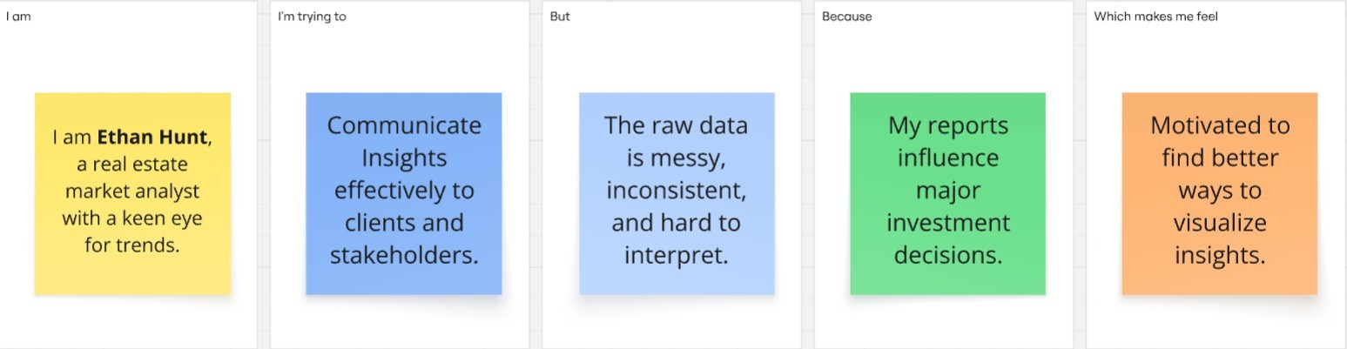

Problem Statemen t | I am (Customer) | I’m trying to | But | Because | Which makes me feel
PS-1 | Ethan Hunt | Communic- ate insights. | The raw data is messy. | My reports influence investment decisions. | Motivated
PS-2 | A real- estate market analyst. | Understand housing market trends. | The raw data is inconsis- tent. | Clients rely on me for insights. | Frustrated

